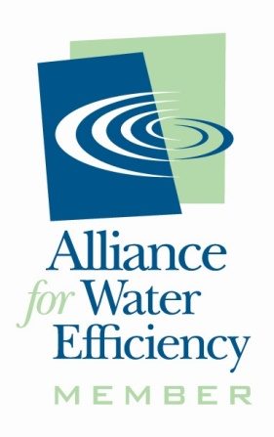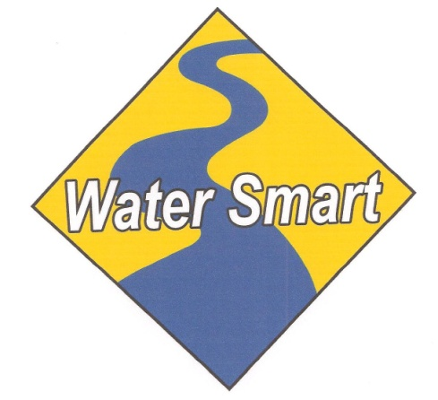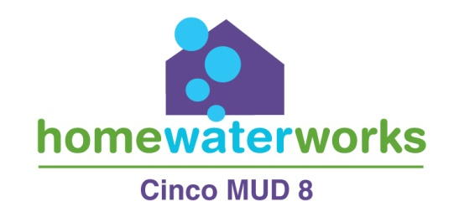
2018 WATER CONSERVATION REBATE FORM
Customer Name: Utility Acct. #
Email Address: Daytime Phone:
Installation Address: Zip Code:
Mailing Address (if different): Zip Code:
Date purchased: Date installed:
Check item installed below: EPA Approved Water Sense products
Must have WaterSense logo:
Bathroom Sink Faucets, Kitchen Sink Faucets, Faucet Aerators–50% rebate up to $50/item
Low Flow Showerheads – 50% rebate up to $40/limit 2
Toilets – 50% rebate up to $200/limit 3
Weather-Based Irrigation Controllers – 50% rebate up to $150, must be listed at www.epa.gov/watersense.
_______Rain Sensor - 50% rebate
_______Toro Precision Spray Heads or Hunter MP Rotators – 50% rebate
_______ Rain Barrels and Diverter – 100% rebate up to $150/limit 2
_______ 50% rebate up to $200 for irrigation upgrades after WISE GUYS free evaluation.
These rebates may be terminated at any time, without notice, by Cinco MUD 8.
Please read the guidelines on page 2 and sign indicating your agreement at the bottom of the page:

- Rebates are available to Cinco MUD 8 single-family residential water customers with an account in good standing.
- Rebates are offered on a first come/first serve basis and are subject to availability of funds. The rebate may be terminated at any time, without notice, by Cinco MUD 8.
- Rebates are credited to utility account listed on the rebate form.
- Prior to issuance of a rebate, a representative from Cinco MUD 8 may conduct a site inspection to verify installation.
- To receive the rebate, you must submit the following:

- Rebate Form (2 pages);
- A dated and itemized receipt (or copy of receipt);
- Photographs after replacement;
- Photo of new item box, showing WaterSense logo;
- Copy of the plumbing repair receipt, if applicable.

Must be submitted to Cinco Municipal Utility District 8 within 90 days of purchase, to:

By Mail: Cinco MUD #8 By Fax: 281-394-4530
c/o Inframark Water Infrastructure Operations Attn: Rebate Program
10431 Westmoor Rd.
Richmond, TX 77407

For more information: http://www.cincomud8.com

I have read and understand the Rebate Program Guidelines and limitations. DB18

Customer Signature: Date:

